 | B.M.S. COLLEGE OF ENGINEERING, BANGALORE-19  Department of Computer Science & Engineering
INTERNALS-1
Course Code: 23CS5PEAAM |  | Course Title: Advanced Algorithms
Semester: V |  | Maximum Marks: 40 | Date: 26-9-2025
Faculty Handling the Course: |  | Dr. Shashikala, Dr. Namratha M,  Dr. Rajeshwari B S, Dr. Jyothi S Nayak
Instructions: Internal choice provided in Part C.

PART-A
Total 5 Marks (No Choice)
No. | Question | Marks | CO | PO | BL
1 | Discuss the principles of dynamic programming. | 5 | 1 | 1 | 2

PART-B
Total 15 Marks (No Choice)
No. | Question | Marks | CO | PO | BL
2a | A safety engineer is tasked with testing the durability of a new type of safety helmet. The company provides him with 2 helmets, and he has access to a 5-story testing tower. The helmets may break if dropped from certain floor. He can certify the durability based on the highest floor the helmet can safely withstand. | 5 | 1 | 2 | 4
2b | Justify how efficiency of Naive Matrix chain multiplication of ‘n’ matrices can be improved using dynamic programming. | 5 | 2 | 2 | 4
2c | Justify how Ford Fulkerson algorithm can be applied for solving multi source and multi sink problem. | 5 | 2 | 2 | 4
PART- C
Total 20 Marks

No. | Question | Marks | CO | PO | BL
3a | A bioinformatics analyst working on comparing DNA sequences and his task is to find similarities between two DNA strands to identify common patterns that might indicate evolutionary relationships. For the given DNA sequences: S1=ACCGGT S2 = GTCGTTCA compute the maximum similarity. Write and analyze the time complexity of the algorithm used. | 10 | 2 | 1 | 3
OR
3b | A material scientist is working in a factory that produces metal rods. Each rod can be sold as a whole or cut into smaller pieces, and each piece has a different market price depending on its length. The goal is to maximize profit from a rod of length 6 using the pricing below:  Devise a dynamic programming-based solution to determine the maximum profit obtainable from this rod. Write and analyze the time complexity of the algorithm used. | 10 | 2 | 3 | 3
  Length | 1 | 2 | 3 | 4 | 5 | 6 | 7 | 8
  Price | 10 | 12 | 4 | 7 | 8 | 14 | 20 | 17
4a | A network engineer has to optimize data transfer through a network. Each connection (edge) between servers (nodes) has a maximum bandwidth capacity, and the goal is to determine the maximum possible data flow from the source server to the destination server.  Apply the Ford-Fulkerson algorithm to find the maximum flow. Show the steps clearly to find the augmented paths, and indicate the final flow values along each connection.  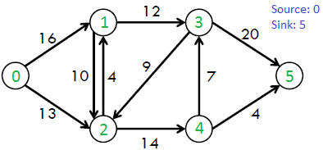 | 10 | 1 | 3 | 3
OR
4b | A planner has to design a optimal path of transporting goods from a warehouse to a retail outlet through a network of intermediate hubs. Each route between hubs has an associated transportation cost, and the network is organized in stages. Determine the optimal path to transport goods from the source to the sink. Using dynamic programming with a forward approach, design an algorithm to solve this problem and apply it to the network provided below.  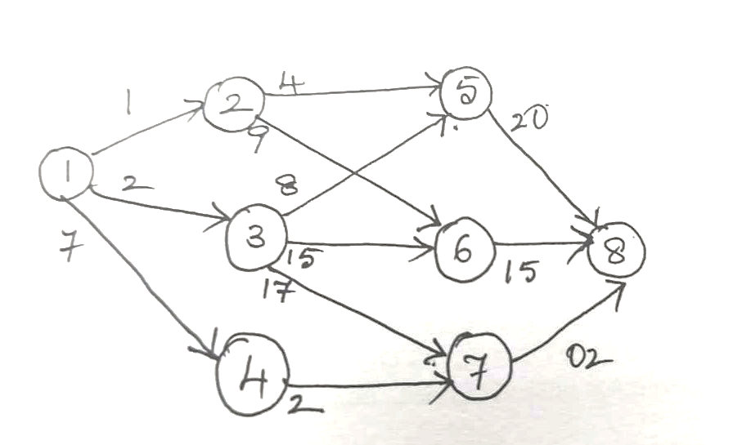 | 10 | 1 | 3 | 3

***ALL THE BEST***

